
Year 7

Investigation In-Class 2020

Number and Algebra

Name: ______________________ Teacher:____________________

Question 1

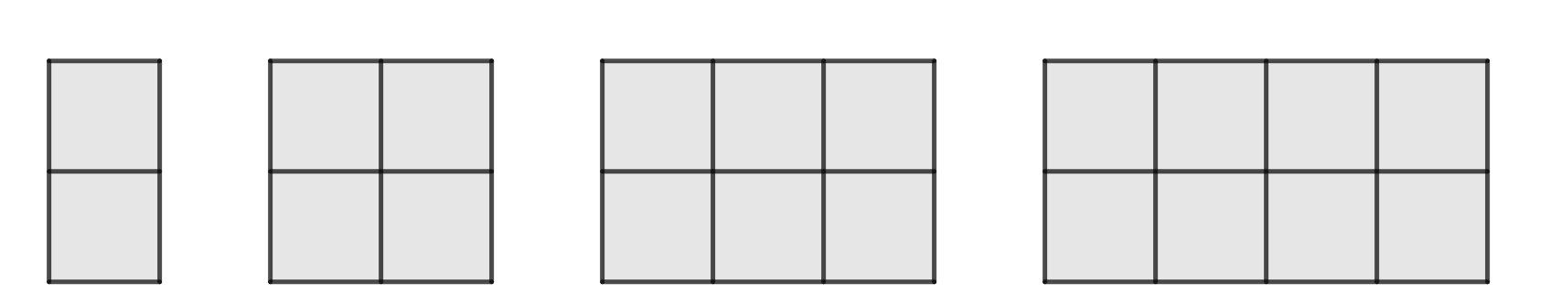
1 2 3 4

- Draw the shape number 5 for the pattern above.

- Complete the table below for the patterns above.

Shape number (n) | 1 | 2 | 3 | 4 | 5 | 6
Area of the shape (A) | 2 | 4

- Describe any pattern that you can see in the table.

- What is the area for shape number 10?

- Write a sentence describing the relationship between the shape number and the area?

- Let n be the shape number and A be the area of shape. Write a rule using symbols and letters between the shape number and area.

- Using your rule, what is the area of shape number 25. (Show your working)

- If the area of a shape is 46, what is the shape number? (Show your working)

Question 2

1 2 3 4

- Draw the shape number 5 for the pattern above.

- Complete the table below for the patterns above.

Shape number (n) | 1 | 2 | 3 | 4 | 5 | 6
Perimeter of the shape (P) | 6

- Describe any pattern that you can see in the table.

- What is the perimeter for shape number 10?

- Write a sentence describing the relationship between the shape number and the perimeter?

- Let n be the shape number and P be the perimeter of the shape. Write a rule using symbols and letters between the shape number and perimeter.

- Using your rule, what is the perimeter of shape number 25. (Show your working)

- If the perimeter of a shape is 110, what is the shape number? (Show your working)

